

BAI211 Artificial Intelligence Fundamentals
First Semester – 2025-2026
Lab Sheet #10

Student ID: ____Bibi Ekhkla Hashimi_____ Student Name: ___202411435_____

Solving Unequal Split Nim Game using Minimax Algorithm

Q1. Solve the unequal split Nim game using Minimax Algorithm in Python. The following are the initial conditions:

- You start as the player “MAX”.
- The game starts with the state [6].

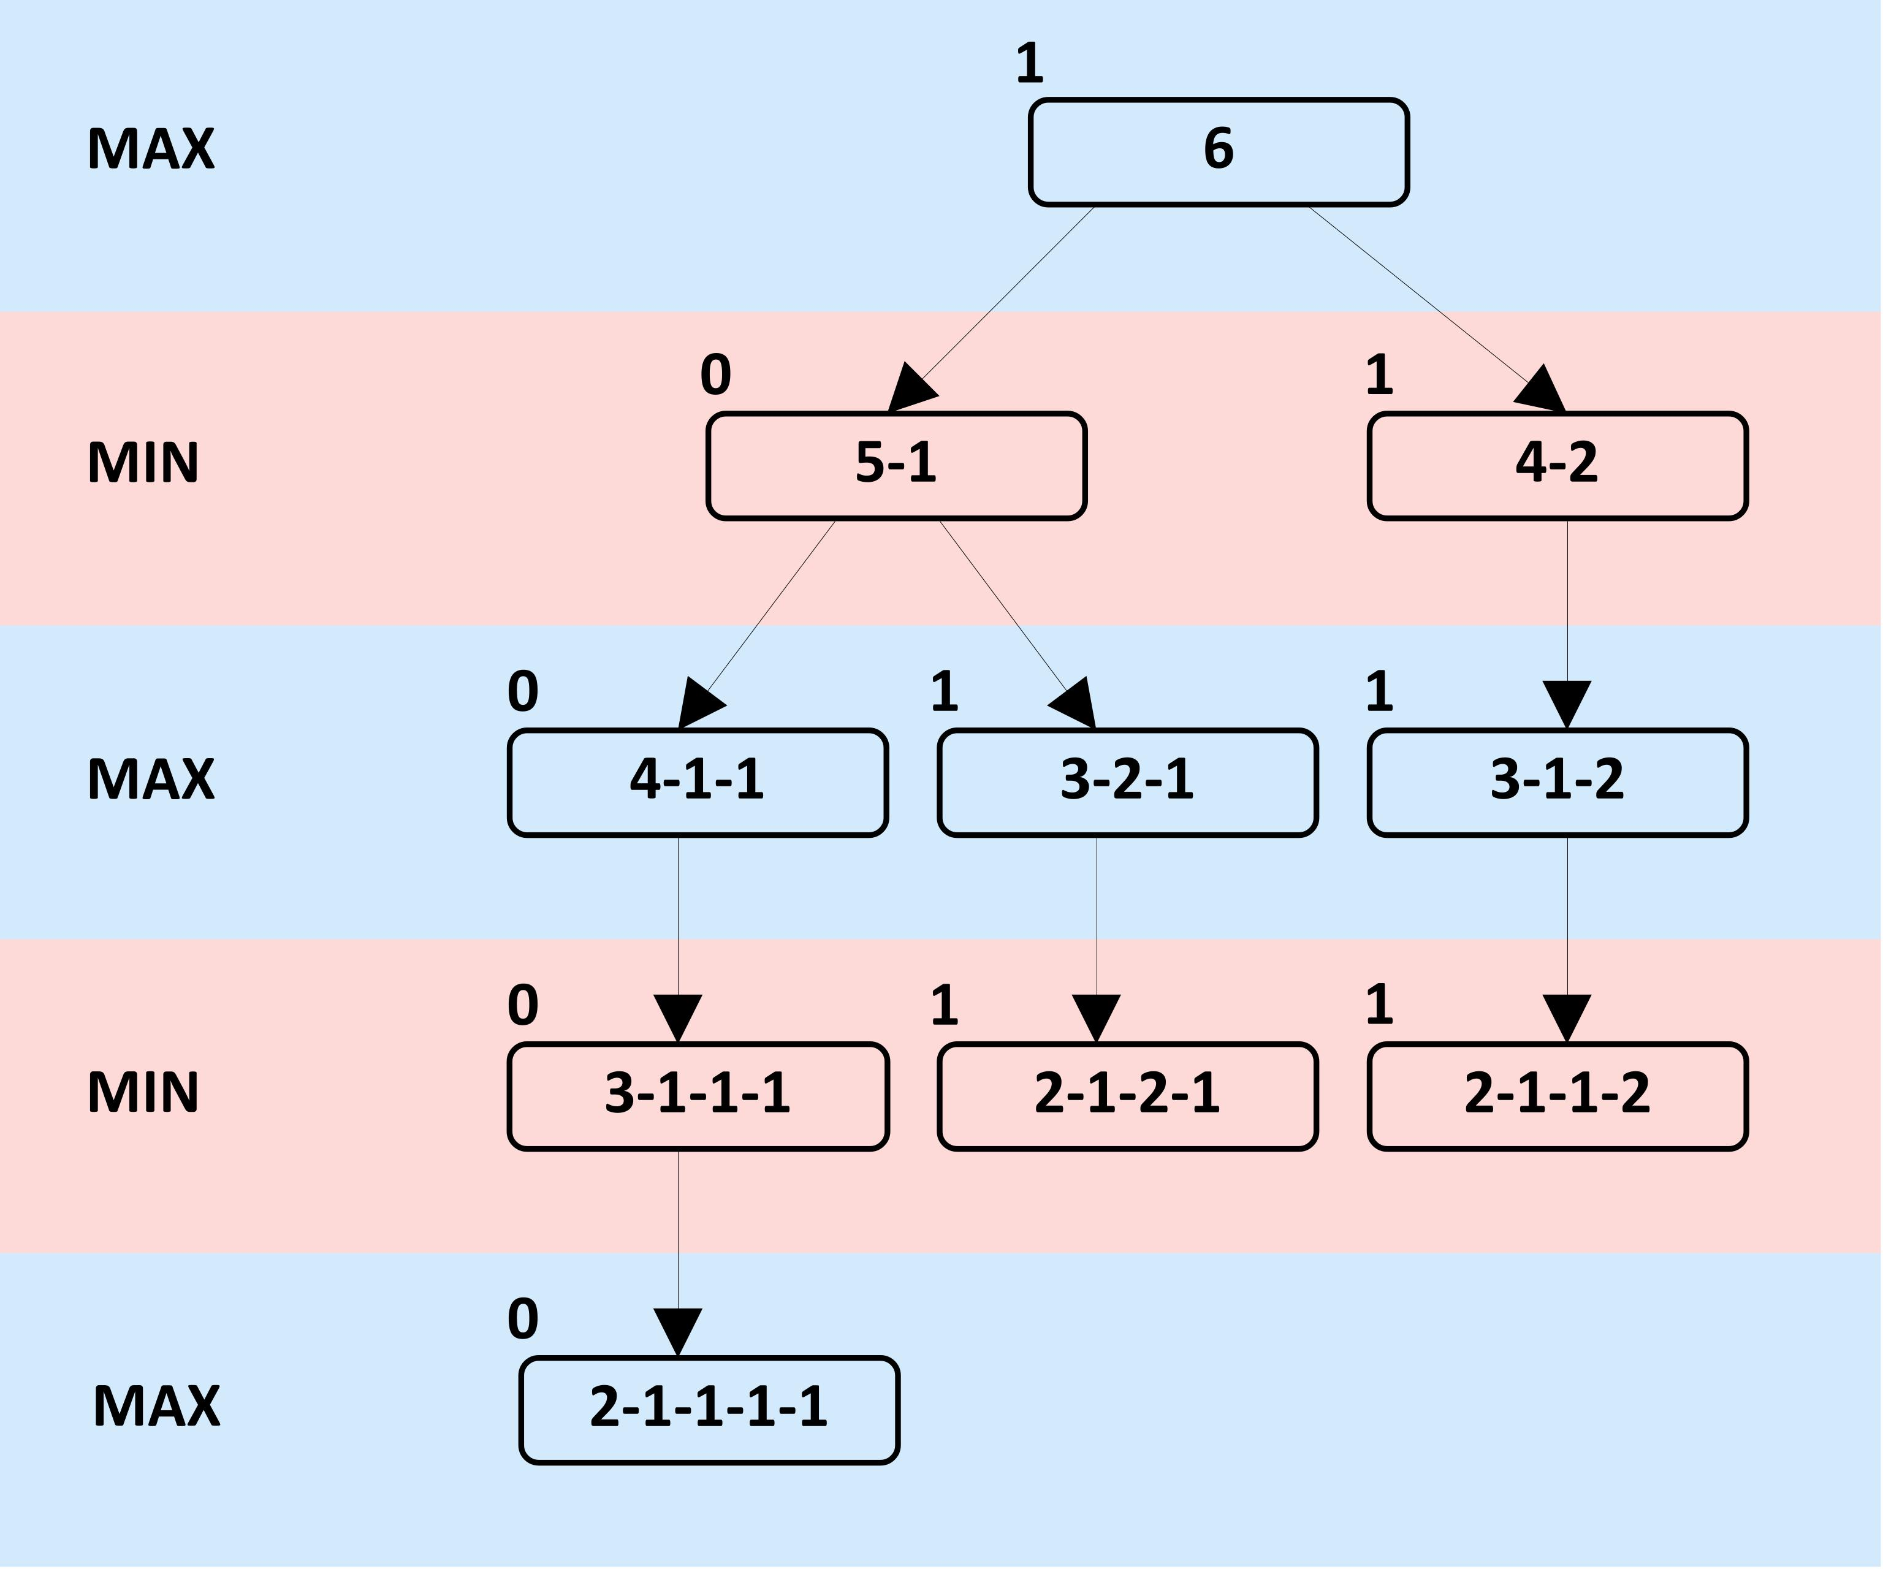

Solution:

Code:
def possible_splits(n):
result=[]
for i in range(1, n // 2 + 1):
j=n-i
if i != j:
result.append([i, j])
return result

def is_terminal(state):
return all(pile <= 2 for pile in state)

def generate_states(state):
next_states=[]

for i, pile in enumerate(state):
for split in possible_splits(pile):
new_state = state[:i] + split + state[i+1:]
next_states.append(sorted(new_state)) # Append a new sorted state to the list
return next_states

def minimax(state, maximizing_player=True):
if is_terminal(state):
return 0 if maximizing_player else 1

if maximizing_player:
best_value = -float('inf')
for child in generate_states(state):
value = minimax(child, False)
best_value=max(best_value,value)
return best_value # Return the best value for the maximizing player
else: # Correctly align the else block for the minimizing player
best_value = float('inf')
for child in generate_states(state):
value=minimax(child, True) # Pass True for the next turn (maximizing player)
best_value=min(best_value, value)
return best_value # Return the best value for the minimizing player

initial_state= [6]
is_max = True

result = minimax(initial_state, is_max)
print(result)

output:
1

